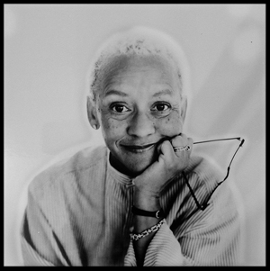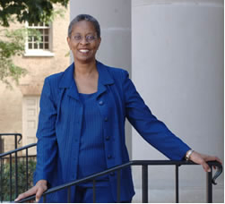
Nikki Giovanni Trudier Harris

The University of North Alabama Writers' Series, under the auspices of the English Department, is pleased to announce that our guests for Spring 2013 (March 13th and 14th) will be Nikki Giovanni and Dr. Trudier Harris.
Nikki Giovanni, author of over thirty books for adults and children is a poet, writer, commentator, activist, and educator. Her autobiography, Gemini, was a finalist for the National Book Award; Love Poems, Blues: For All the Changes, Quilting the Black-Eyed Pea, Acolytes, and Hip Hop Speaks to Children: A Celebration of Poetry With A Beat were all honored with NAACP Awards. Blues: For All the Changes reached #4 on the Los Angeles Times bestseller list. Her children's picture book, Rosa, became a Caldecott Honors Book and reached #3 on The New York Times bestseller list.
Dr. Trudier Harris, a native Alabamian, is the author, co-author, and editor of multiple books on African-American Literature. Her memoir, Summer Snow: Reflections from a Black Daughter of the South, was published by Beacon Press in 2003, and selected as the inaugural text for the "One-Book, One-Community" reading project in Orange County, North Carolina. She was selected for the Eugene Current-Garcia Award for Alabama's Distinguished Literary Scholar in Spring 2002. Professor Emeritus at the University of North Carolina-Chapel Hill, she currently teaches at the University of Alabama - Tuscaloosa.
On March 13th, at 2 pm in the Loft of the Guillot University Center, Dr. Lisa Graves-Minor and Dr. William Verrone, of UNA's English Department will present introductions to Ms. Giovanni's work with the spoken word and in film. Ms. Latasha Howell, also a member of UNA's English Department, will moderate.
On March 14th, at 9:30 in the Performance Center of the GUC, Dr. Harris will read from her poetry and a work in progress.
On March 14th, at 11 am in the Performance Center of the GUC, Nikki Giovanni will read from her poetry.
A book-signing and reception will follow in the Loft of the GUC.
All events are free and open to the public.
The Writers' Series is being underwritten, in part, by grants from the Alabama Humanities, Foundation, and the Alabama State Council on the Arts.

